Cables and Conductors

1
What is the purpose of circuit shielding and of housing a circuit in a conductive chassis?

To form a conductive shield around the cable and circuitry to isolate it from airborne interference

2
In a series of circuits, what is usually referred to as the “common” connection?

The conductor which is a common (reference) voltage, typically 0 volts. It may be earth potential, but this may cause other issues in certain circumstances (earth loops resulting in mains hum)

3
What is the difference between an electrical supply ring, star and spur?

Ring – typically all electric outlets are connected in a string which leads back to the distribution unit (fusebox, consumer unit)

Star – all outlets are served from the consumer unit in a radial (star) arrangement

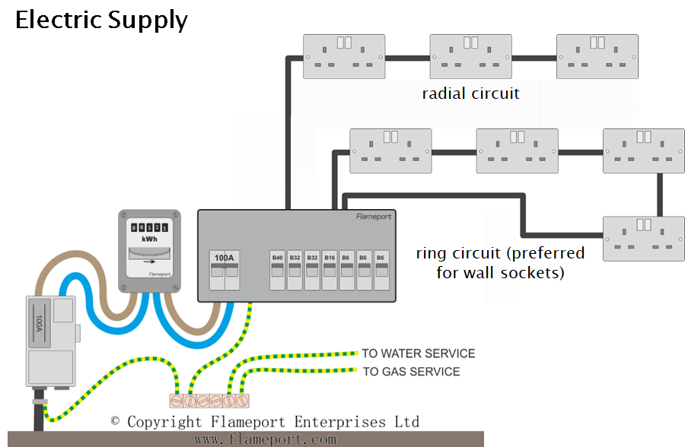

4
Compare and comment on the performance of cables in a cable bundle which are (i) common shielded, and (ii) individually shielded.
- common shielded
all are shielded from external interference, but may still crosstalk to each other

- individually shielded
all are shielded from external interference, and also shielded from crosstalk to each other
… but more expensive

5
Explain the occurrence of ground loops in interconnections connections between audio equipment

Ground loops occur when two equipment units are on the same distribution run, but separated sufficiently that there is a voltage difference in the supply run. This then produces a current in the supply loop points between the equipment units

6
What is the relationship between the turns ratio of a transformer and the voltages on each winding.

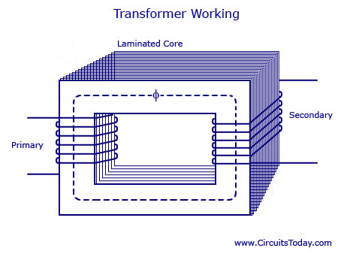

The ratio of input voltage to the output voltage is the same as the ratio of the primary turns to the secondary turns, i.e.
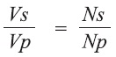

And also

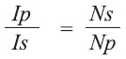

7
Compare balanced and unbalanced connections between equipment.
Explain differential signal and how this is employed in balanced connections to avoid interference.

Unbalanced (typically consumer grade) – common connection is the shield
The signal is sent on the single signal connector

Balanced – the signal is sent on two connectors (“hot” and “cold”) – sent in a differential format, i.e. two complementary 180° phased signals
The two connectors are shielded by a third lead. Typically connected in XLR connector format. Differential signals allow interference from a common source to be cancelled in the differentiation process at each end of the cable.
The differential circuit was traditionally a transformer – typically an audio 1:1 transformer, centre tapped to allow the signal to be transformed from unbalanced (in the microphone to balanced on the balanced link, and back to unbalanced in the receiver.
Other electronic circuits are available to undertake the process.
Note that if a transistor/op amp circuit is used, this will require its own power and also will have operational issues: transistor circuits inevitably introduce distortion, albeit very low level; but they’re much more convenient (cost and space).
(see lecture notes)

8
Describe how phantom power is implemented.

Phantom power is applied over a balanced connection which allows the voltage over the signal path to be raised to a DC level which can be utilised by the equipment requiring power (typically a condenser microphone).
Phantom power is typically 48V DC (industry standard).
The differential circuits at each end allow the voltage to be added at the sender (typically a mixer or pre-amp) and deduced at the receiver end (the microphone). The actual a.c. signal is “unaware” of the DC level being applied. The signal just “sits” on top of the phantom voltage, and can be easily received at the receiver (pre-amp or mixer).
(see lecture notes)

